1.

You are a modern day superhero, trying to hack into the supervillain’s supercomputer. You have discovered that their supercomputer reads a string from standard input, using a function called “**Gets**” that is curiously identical to the one used in a class project from college, many years ago. The supercomputer uses **randomization**, and also marks the section of memory holding the stack as **non-executable**.

Thanks to the sacrifice of your trusty sidekicks, hotdog-man and one-punch-man, you managed to learn that the **buffer size of the “Gets” function is 32 bytes**. Furthermore, you learned the address and machine instructions of the following two functions:

0000000000401900 <boomBoomBOOM>:

401900: 55 push %rbp

401901: 48 89 e5 mov %rsp,%rbp

401904: b8 48 89 c7 90 mov $0x90c78948,%eax

401909: 5d pop %rbp

40190a: c3 retq

000000000040190b <bangBangBANG>:

40190b: 55 push %rbp

40190c: 48 89 e5 mov %rsp,%rbp

40190f: 48 89 7d f8 mov %rdi,-0x8(%rbp)

401913: 48 8b 45 f8 mov -0x8(%rbp),%rax

401917: c7 00 58 90 90 c3 movl $0xc3909058,(%rax)

40191d: 90 nop

40191e: 5d pop %rbp

40191f: c3 retq

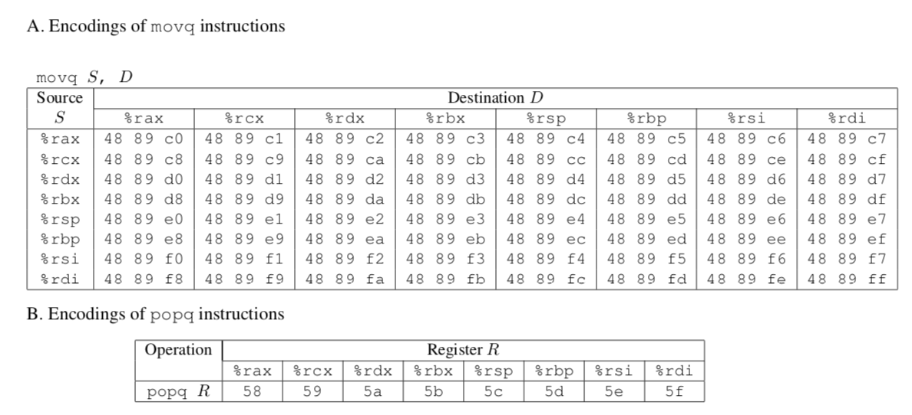



In order to save your city, you need to call a function with the address **0x400090**, that takes the number “**12345**” as input. **What should your input string be**, in order to execute that function with the appropriate input?

2.

#include < stdio.h >

int main(void)

{

#pragma omp parallel

{

printf("Hello, world.\n");

}

return 0;

}

After compiling the program and running it, you get the output:

Hello, world.

Hello, world.

You run the program again and the output this time is:

Hello, Hello, woorld.

rld.

Explain this behavior.

3.

Take a look at the following OpenMP usages.

a.

Is there a difference between the two following codes? We want func() to be called 10 times.

**#pragma omp parallel num_threads(2)**

**{**

**...**

**#pragma omp parallel for**

**for (int i = 0; i < 10; i++)**

**{**

**func();**

**}**

**}**

Vs.

**#pragma omp parallel num_threads(2)**

**{**

**...**

**#pragma omp for**

**for (int i = 0; i < 10; i++)**

**{**

**func();**

**}**

**}**

b.

What is the issue with the following code? What can we do instead?

#pragma omp parallel

{

omp_set_num_threads(2);

#pragma omp for

for (int i = 0; i < 10; i++)

{

func();

}

}

4.

Consider the following function. How might we optimize it using OpenMP?

void func3(double *arrayX, double *arrayY, double *weights,

double *x_e, double *y_e, int n)

{

double estimate_x=0.0;

double estimate_y=0.0;

int i;

for(i = 0; i < n; i++){

estimate_x += arrayX[i] * weights[i];

estimate_y += arrayY[i] * weights[i];

}

*x_e = estimate_x;

*y_e = estimate_y;

}

5. **OPTIONAL**

a.

The four conditions under which deadlock occurs are:

1. Mutual Exclusion
2. Incremental (or partial) Allocation
3. No pre-emption
4. Circular Waiting

What do these conditions mean? In what ways (if at all) can these conditions be useful?

b.

Bored of blowing bubbles, Spongebob and 4 of his friends decide to make krabby patties instead. To make krabby patties, one needs 2 spatulas, both at the same time. However, they discover that they only have 5 spatulas total.



Grill

Grill

Grill

Grill

Grill

Each of Spongebob and his friends can only grab one spatula at a time, and can only grab spatulas to their left and right. All of them prefer to pick up the left spatula first, then the right. They refuse to forcefully take away spatulas from each other, lest they break their friendship, and will pick up a spatula only if it is not being held. Once they have even one spatula, they refuse to let go of it until they can make a krabby patty.

Is this situation considered a deadlock? Why or why not?

If so, how does it fit into the four conditions for deadlock? How can we resolve it?

If not, what about this situation helps Spongebob avoid deadlock?